

|  |
| --- |
| Report Digital Logic Design  Password Security System |
|  |
| May 22  Group Members:   1. Sara Tariq 2. Khudema Haroon 3. Noor Malik 4. Ghulam Qadir 5. Muqeem Ahmed     COMPANY NAME  Authored by: Your Name |



# *Project Title:*

# Design and Implementation of a Password Security System:

1. Task Description:

Firstly, we connected 4 AND gates. The output of the AND gate is made 1 in a way that if we want to enter the password as 2942 then we set the input according to the binary code of the numbers displayed on the 7 segment display. For example, the digit displayed is 2 and the binary of 2 is 0010 then the Not gate is connected with the input at 0 so that its output 1 moves on to AND gate. Then further the outputs of all AND gates are connected to the next AND gate. Moreover, the LED both Red and Green are connected at end such like Green LED is connected as it is but the Red LED is connected with the NOT gate so that the output can be inverted. The main purpose of connecting the LEDs is that it shows whether the password entered is correct or not. Finally the inputs are connected to the BCD decoder IC and further connected to 7 segment display that shows the number of the password.

1. Theory of Operation:

The system functions by comparing the entered password with a predefined password (the last four digits of the registration number). If the passwords match, the green LED illuminates. If they do not match, the red LED and buzzer are triggered. The entered password is continuously displayed on the seven-segment display.

1. Breakdown of Tasks:

* Conduct research on digital logic design.
* Create the combinational and sequential circuit designs.
* Simulate the circuits using Proteus software.
* Build the circuit on a breadboard.
* Test the circuit in a practical setting.
* Document the design and testing stages.
* Develop a presentation and report.

1. Block Diagram of the Design:

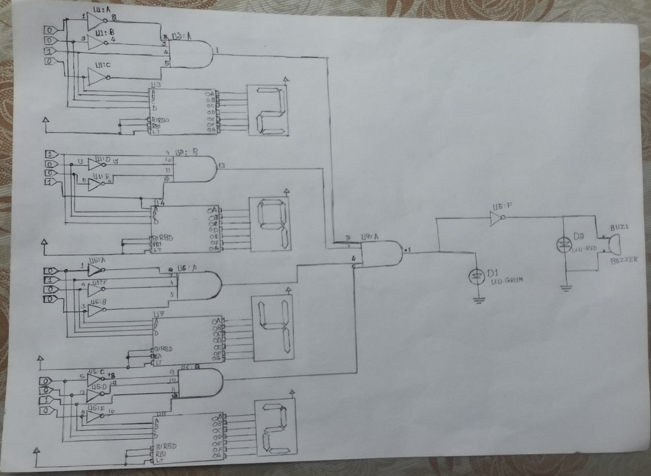

1. Design Details:

Components Used:

* Logic gates (4 Input AND Gates, NOT)
* BCD decoder
* Seven-segment
* LEDs and buzzers

Design Process:

Step 1: Develop the logic equations for the circuit.

Step 2: Design the circuit using logic gates

Step 3: Integrate the seven-segment display along with BCD decoder to show circuit

Step 4: Add the LEDs and buzzer for output

1. Design Schematics for All Modules:

[Insert Schematic Diagrams Here]

Labeling:

Ensure all input and output connectors are labeled with proper signal names.

Label any internal signals used in logic expressions.

1. Simulation Screenshots:

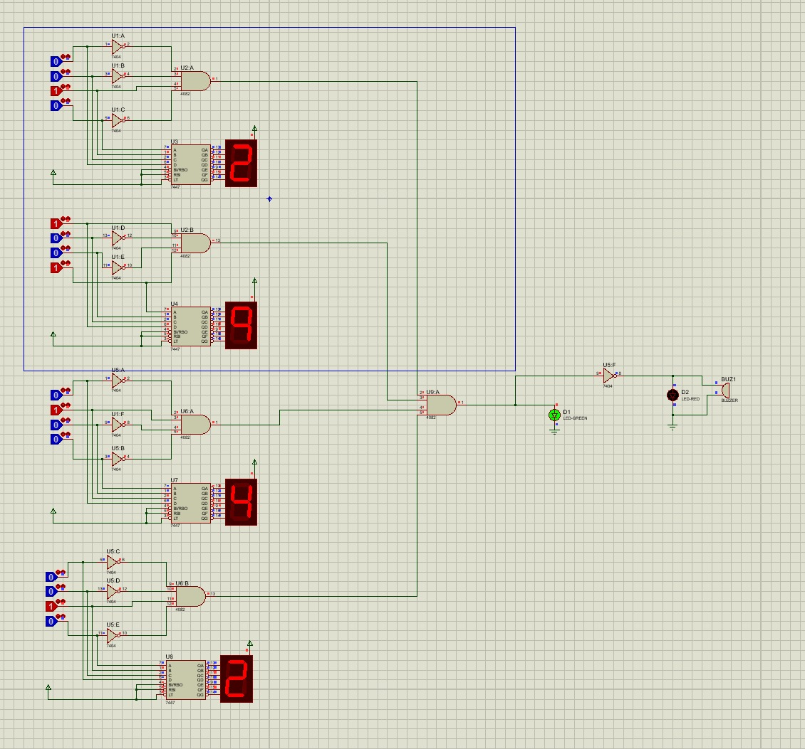

1. Testing and Results:

Describe the process of assembling the circuit on a breadboard.

Provide details of the physical testing process and results.

[Insert Photos of the Breadboard Setup and Testing Here]

1. Conclusion:

In conclusion, the semester project for the Digital Logic Design lab effectively demonstrates the design and implementation of a password security system. By using the last four digits of the registration number as the password, the system displays the entered password on seven-segment displays. The project successfully meets its objectives by activating a vivid red LED and a resonating buzzer for incorrect password entries, while a green LED indicates a correct entry.